H.T No
Regulations:
A20

Sreenidhi Institute of Science and Technology
(An Autonomous Institution)
Code No: 8B205 Date: 28-Mar-2023 (AN)

B.Tech I-Year II- Semester External Examination, March/April-2023 (Supplementary)
MECHANICS OF SOLIDS (ME)

Time: 3 Hours Max.Marks:70

Note: a) No additional answer sheets will be provided.
b) All sub-parts of a question must be answered at one place only, otherwise it will not be valued.
c) Missing data can be assumed suitably.
Bloom's Cognitive Levels of Learning (BCLL)

Remember | L1 | Apply | L3 | Evaluate | L5
Understand | L2 | Analyze | L4 | Create | L6

Part - A Max.Marks:20

Answer all QUESTIONS.

 |  | BCLL | CO(s) | Marks
1 | Define poisson’s ratio and explain its significance. | L1 | CO1 | [2M]
2 | Explain the significance of Mohr’s circle and its uses. | L4 | CO2 | [2M]
3 | Give the relationship between B.M. & S.F. and rate of loading in a beam. | L3 | CO3 | [2M]
4 | What is a shear center? Explain. | L3 | CO4 | [2M]
5 | Write the differential equation of deflection of a bent beam? | L3 | CO5 | [2M]
6 | Distinguish between thin walled cylinder and thick walled cylinder. | L4 | CO6 | [2M]
7 | Calculate the diameter of a circular bar of length 10m, if the elongation of the bar due to an axial load of 100kN is 0.15mm. E=200GN/m² | L3 | CO2 | [2M]
8 | Sketch any 2 types of supports used for a beam indicating the reactions in each case. | L3 | CO4 | [2M]
9 | Define circumferential stress and longitudinal stress. | L1 | CO5 | [2M]
10 | A cantilever beam of span ‘L’ is subjected to a concentrated load ‘w’ at free end. What would be the maximum slope and deflection. | L4 | CO6 | [2M]

Part – B Max.Marks:50
ANSWER ANY FIVE QUESTIONS. EACH QUESTION CARRIES 10 MARKS.

 |  |  | BCLL | CO(s) | Marks
11. | a) | Sketch and explain stress-strain diagram for mild steel. | L3 | CO1 | [5M]
 | b) | Calculate the total deformation of the bar shown in fig. What will be the diameter of a bar of uniform cross section, to have the same strain as that of the stepped bar? Take Young’s modulus as 200 GPa.  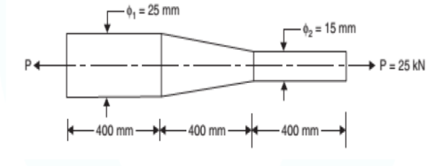 | L4 | CO1 | [5M]
12. | a) | A hollow shaft of external diameter 120mm transmits 300kW power at 200rpm. Determine the maximum internal diameter if the maximum stress in the shaft is not to exceed 60N/mm² | L3 | CO2 | [5M]
 | b) | A solid steel shaft has to transmit 75kW at 200rpm. Determine the suitable diameter of shaft if the maximum torque transmitted is not to exceed the mean by 30% in each revolution. The shear stress is not to exceed 70N/mm². Also calculate the maximum angle of twist in a length of 4m of the shaft. G=80Gpa | L3 | CO2 | [5M]
13. | a) | Determine the load P such that reactions at supports A and B are equal in the beam shown in fig.Draw the shear force and bending moment diagrams and mark the values at salient points.  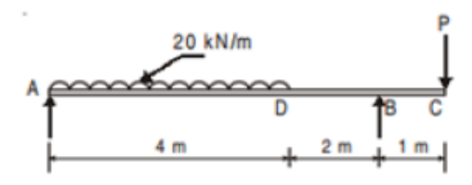 | L4 | CO3 | [5M]
 | b) | A beam 6m long and simply supported at each end has a uniformly distributed load of 800 N/m extending from the left end to a point 2 m away. There is also a clockwise couple of 1500 Nm. applied at the centre of the beam AB. Draw the shear force and bending moment diagrams for the beam and find the maximum bending moment. | L3 | CO3 | [5M]
14. | a) | Draw the bending stress distribution for a symmetrical section. | L3 | CO4 | [5M]
 | b) | A simple beam of span 10m carries a udl of 3kN/m. The section of the beam is a T section having a flange of 125x125mm and web 25x175mm. For the critical section obtain the shear stress at the neutral axis and at the junction of flange and the web. Also draw the shear stress distribution across the section. | L4 | CO4 | [5M]
15. | a) | A steel cantilever of 2.5m effective length carries a load of 25kN at its free end. If the deflection at the free end is not exceed 40mm. What must be the I value of the section of the cantilever. Take E = 210 GN/m² using moment area method. | L3 | CO5 | [5M]
 | b) | A beam of length 6m is simply supported at its ends and carries a point load of 48kN and 40kN at a distance of 1m and 3m respectively from the left support. Find  i) Deflection under each load  ii) Maximum deflection  iii) Point at which maximum deflection occurs by double integration method. Given E=2x10⁵N/mm² and I=85x106mm⁴. | L4 | CO5 | [5M]
16. | a) | A 2m long thin cylindrical shell (both ends closed), internal diameter 90cm and thickness 12mm, is subjected to internal pressure 2N/mm². Find  - Hoop and longitudinal stresses,  - Changes in diameter and length shell.  Take E = 2×10⁵ N/mm² and Poisson’s ratio = 0.3. | L4 | CO6 | [5M]
 | b) | Derive an expression for maximum principal stress in a thick cylindrical shell subjected to internal pressure only | L3 | CO6 | [5M]
17. | a) | A rod is 2 m long at a temperature of 10°C. Find the expansion of the rod when the temperature is raised to 80°C. If this expansion is prevented, find the stress induced in the material of the rod. Take E=1x10⁵N/mm² and α=0.000012 per degree centigrade. | L3 | CO1 | [4M]
 | b) | Draw the Mohr’s circle for a state of pure shear and indicate the principal stresses. | L3 | CO2 | [3M]
 | c) | A cantilever beam of span 4m is subjected to a udl of 2 kN/m over its entire length. Sketch the bending moment diagram for the beam. | L3 | CO3 | [3M]
18. | a) | Derive and explain the classic bending equation. | L4 | CO4 | [4M]
 | b) | Why moment method is more useful when compared with double integration? | L4 | CO5 | [3M]
 | c) | Write the equation of longitudinal strain in a cylindrical shell, which is subjected to an internal fluid pressure ‘P’ | L2 | CO6 | [3M]

-- 00 -- 00 –

